Southery Academy PE Report 2022-2023
Throughout 2022 and 2023, we have worked extremely hard as a school to improve the provision of PE and Sport at Southery Academy. I have listed some notable changes and achievements throughout this academic year below:
- Southery Academy have been awarded a GOLD award for Norfolk School Games and Norfolk Shooting Stars
- PE Lead (Mr. Bothamley) has completed a Head of Sport webinar
- PE Instructor (Mr. Norris) has completed an extensive AFPE Level 3 qualification
- Continued to implement and adapt the PE curriculum alongside the PE Passport and working wall, this now runs in line with other curriculum areas by using the subject map showing composites and components linked to events, seasons and other class composites
- Two PE iPads are now used to plan, monitor, adapt and assess PE by the instructor and subject leader
- PE working wall is now developed to promote aspirational outcomes in PE and sport
- Sports events wall is up and updated frequently to celebrate successes
- PE Store and PE shed are organised with up to date equipment ready to be used
- Completed the annual PE equipment audit leading to ordering new/replacement equipment
- Restarted and extended the offer of extra-curricular after school multi-sports and competition preparation clubs
- Implemented lunchtime sports activities and event trials
- Y5 children have completed the Young Leader’s Course, qualifying as playleaders leading to a new playleader rota and child-led activities being implemented in September
- The transition has started to move the PE subject leader folder to online to improve staff workload
- A monitoring schedule is in place to manage the provision of PE teaching
- Improved the way that the Sports Premium budget is managed, planning ahead with a financial plan with sustainability in mind
- Order of of new playtime and lunchtime play equipment to support playleaders and our PE instructor
- Playtime and lunchtime equipment boxes have been sorted by playleaders and PE staff
- Success in a competition to win a new Nike sports kit
- Every child in the school has been given the opportunity to participate in at least one extra-curricular event or competition
- Competed in competitions with more children being able to reach next level events
- Competed in interclass competitions
- Started to develop staff progression through the use of CPD
- Changed the venue for swimming to improve quality of provision and to increase the number of children attending each week, as well as changing the year group to reflect data accurately as well as give the Year 5s a chance to develop before they reach Year 6
- Started the tracking and assessment of PE progress, identifying gaps and key information
- Implemented the same ‘Good to be Green’ behaviour system used in all lessons that mirror class systems
- Held a whole-school PE assembly to re-establish expectations and promote key values/opportunities
- Updated and improved PE risk assessments to reflect current situations
- We participated in a EMAT Games challenge
- Sports Week was a huge success with children enjoying their time competing and participating in new sports, competing against each other learning about new sports
- Our annual Sports Day was a huge success, receiving fantastic feedback from children, parents and staff

See below data for the whole school’s PE attainment, as well as data from extra-curricular clubs and events/competitions.
PE composites covered:
Fine Motor Skills | Gymnastics | Athletics
Fundamental Movement Skills | Target Games | Tennis
Cross Country (HRF) | Net & Wall Game Skills | Cricket
Yoga | Basketball | Striking & Fielding
OAA | Dodgeball | Swimming
New Age Kurling | Badminton | Rounders
Speed Stacking | Netball | Athletics

Whole-School PE attainment:
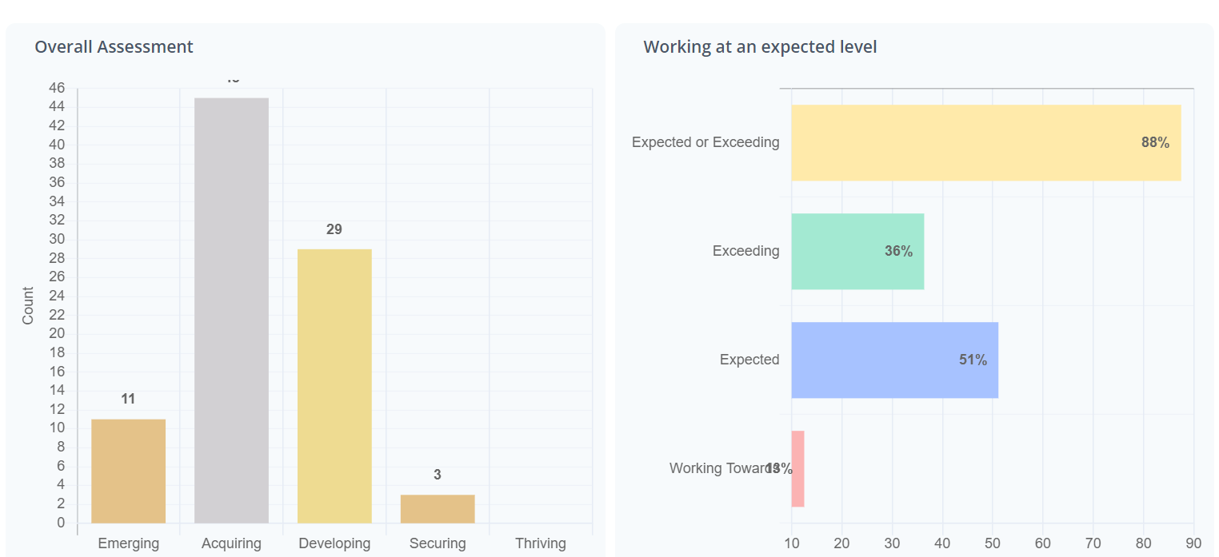
Reception:

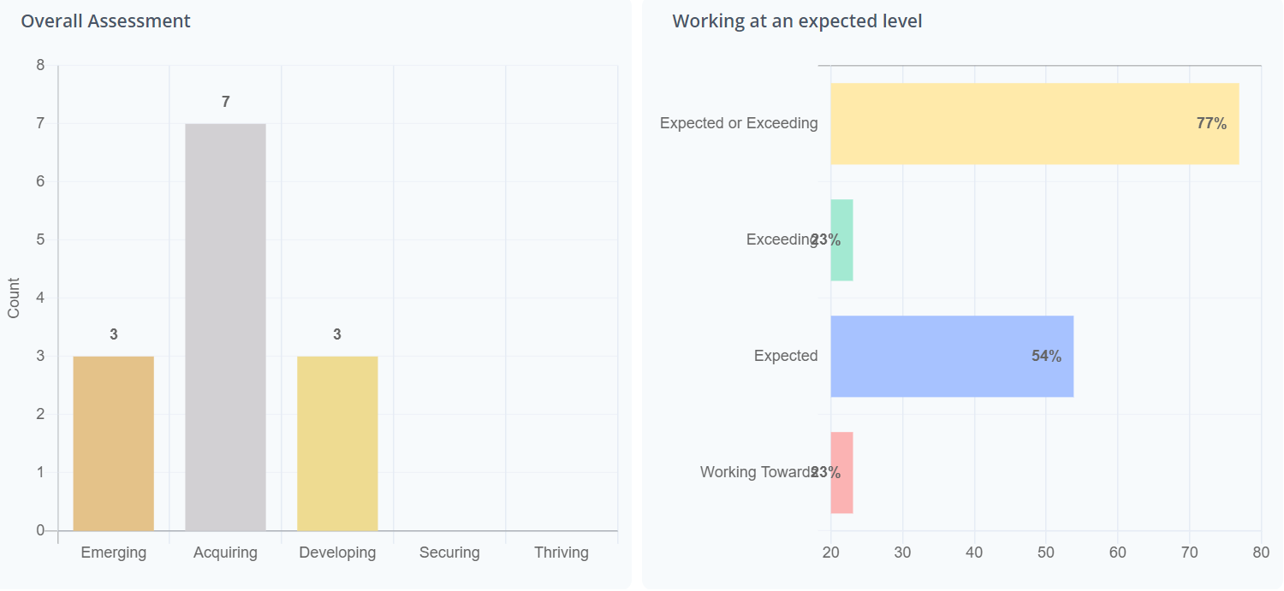

Year 1:
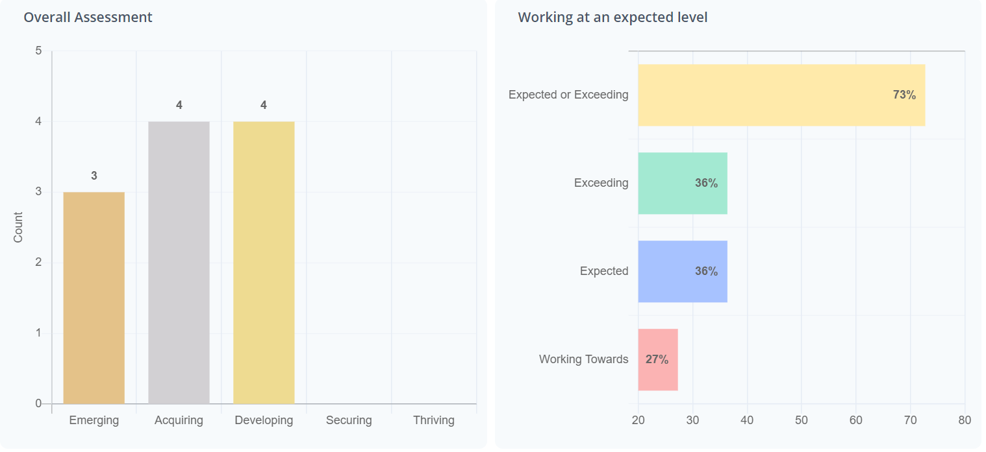

Year 2:
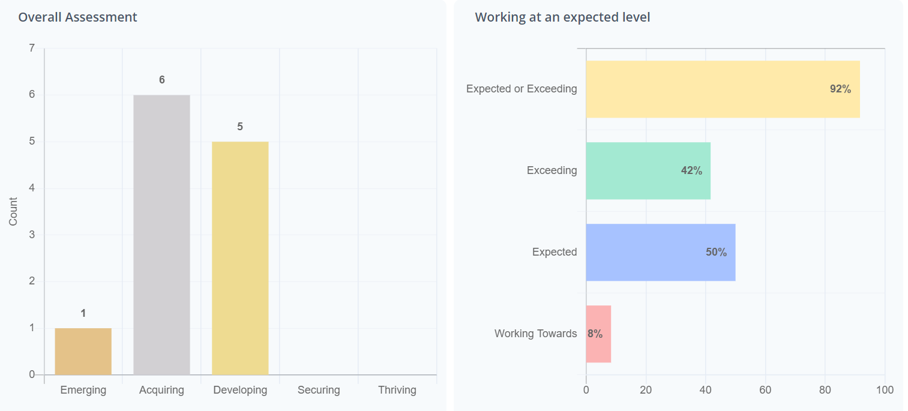

Year 3:
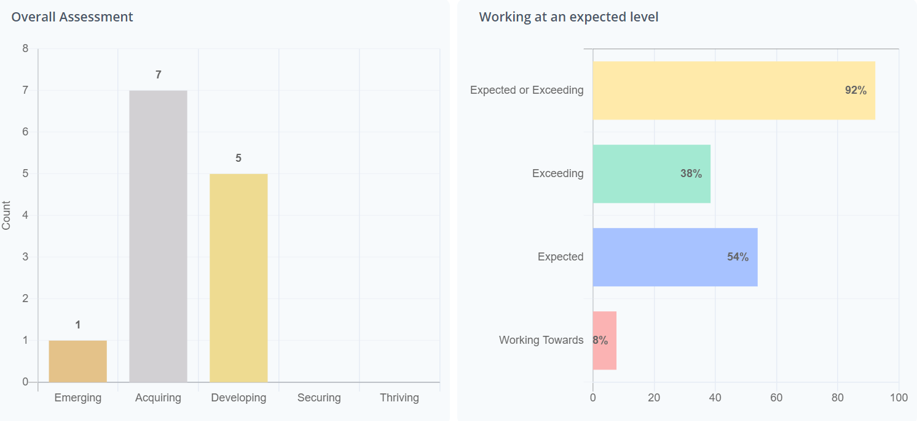
Year 4:
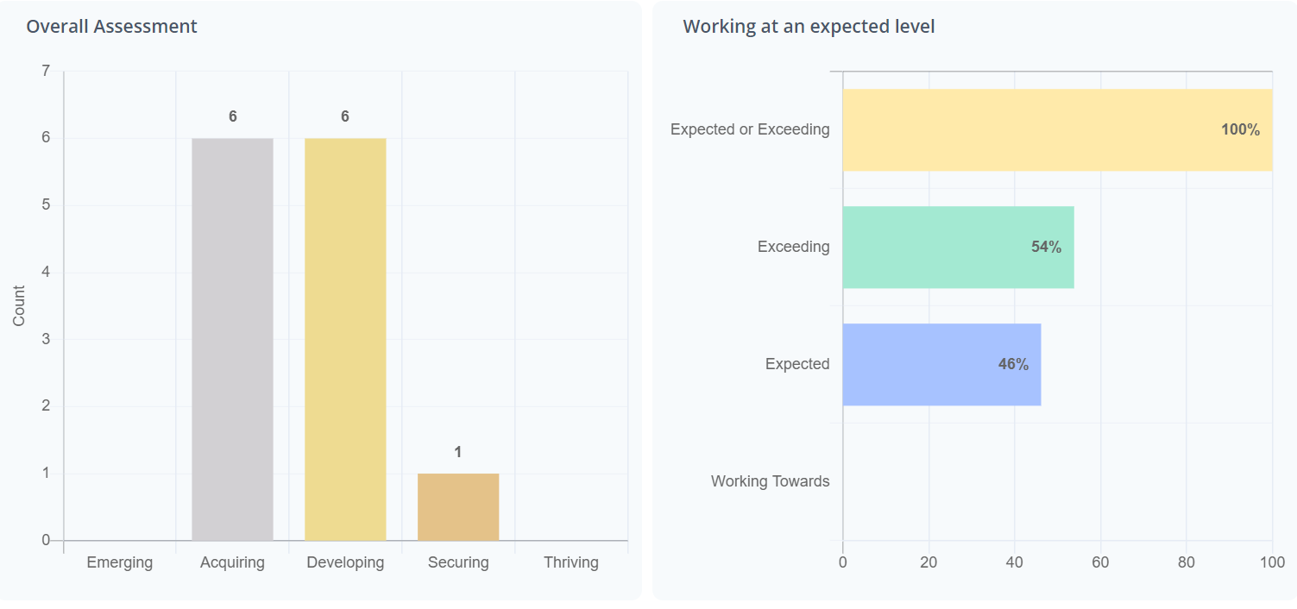

Year 5:
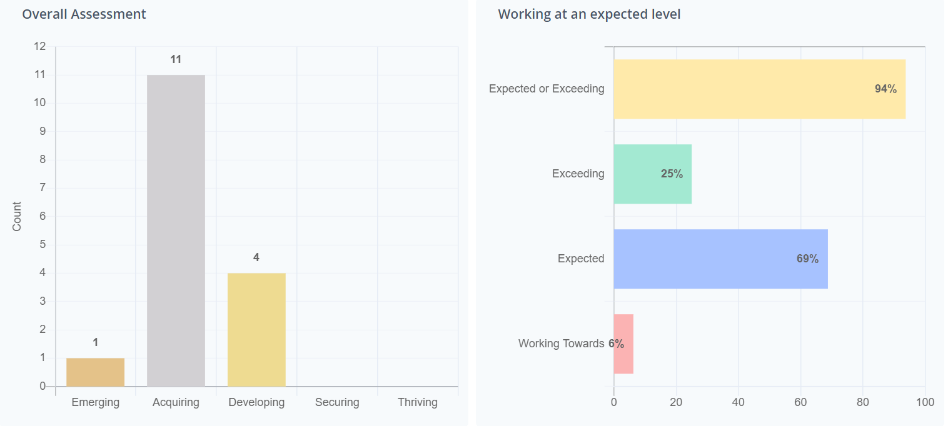
Year 6:
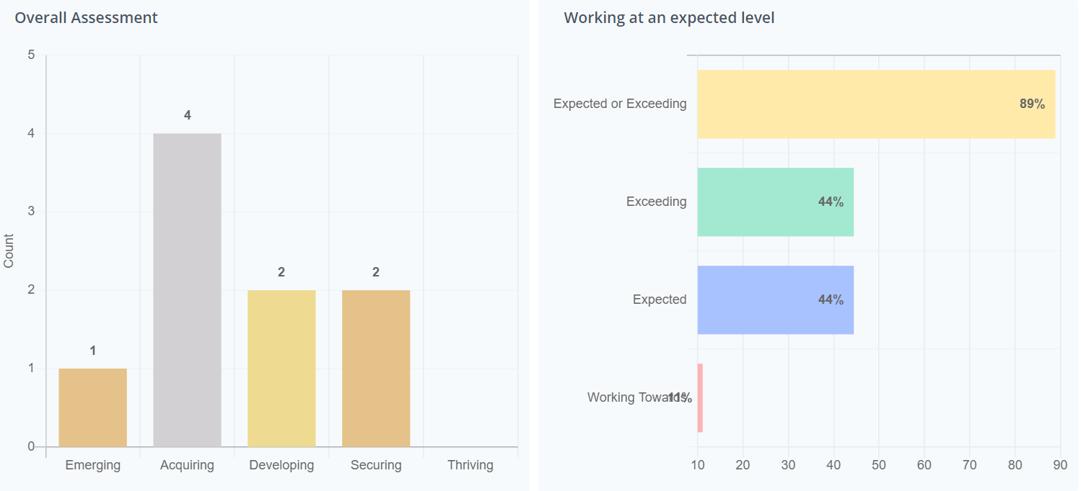

Male:
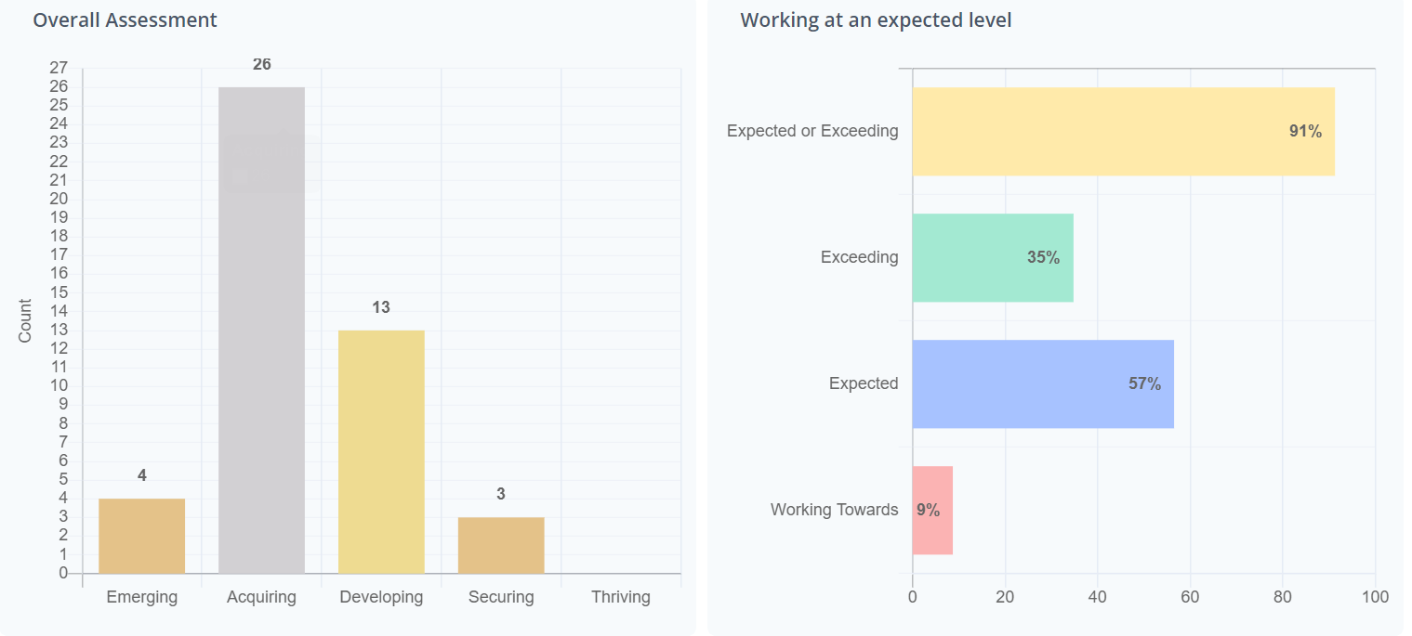
Female:
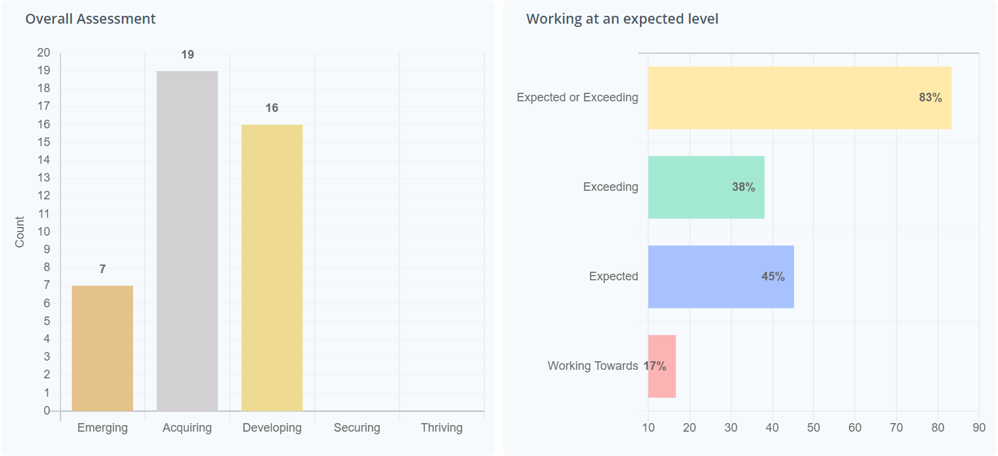

Pupil Premium:
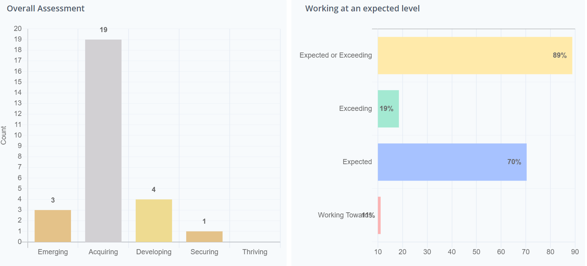
SEND:
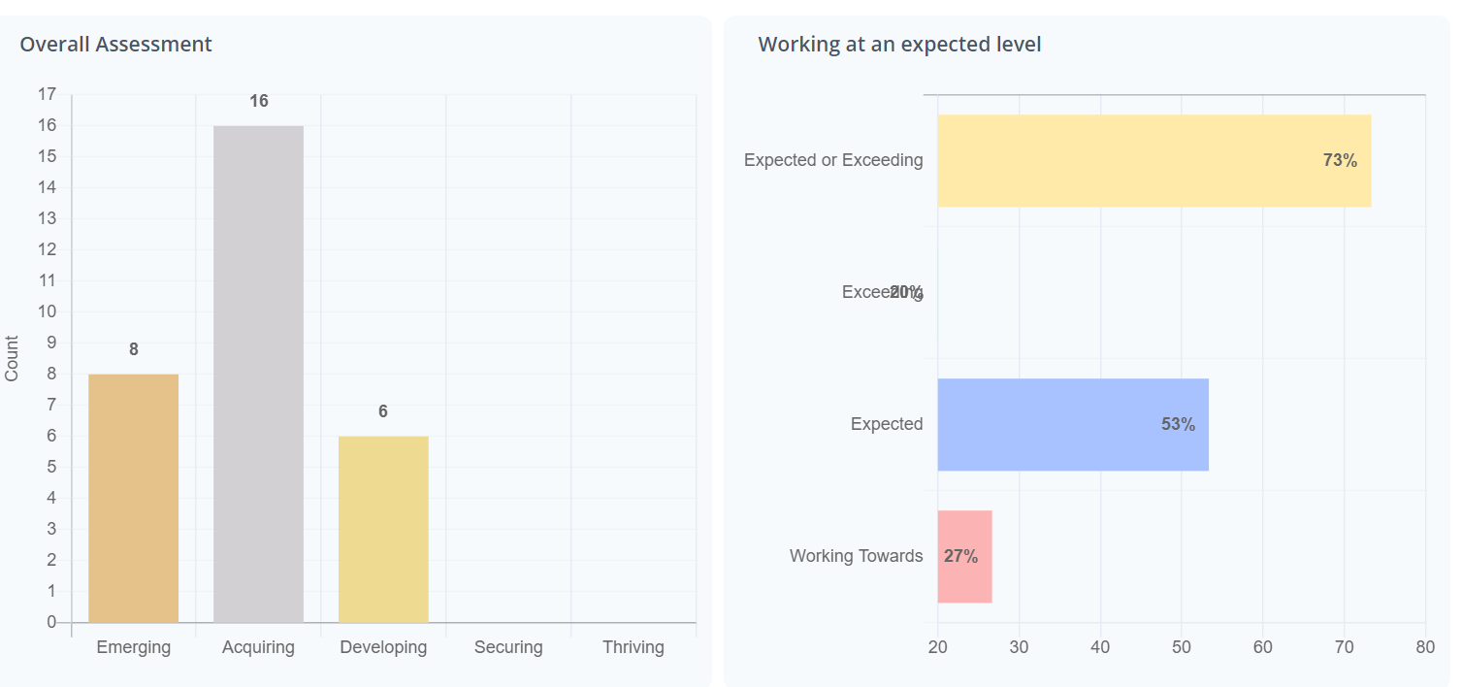

EAL:
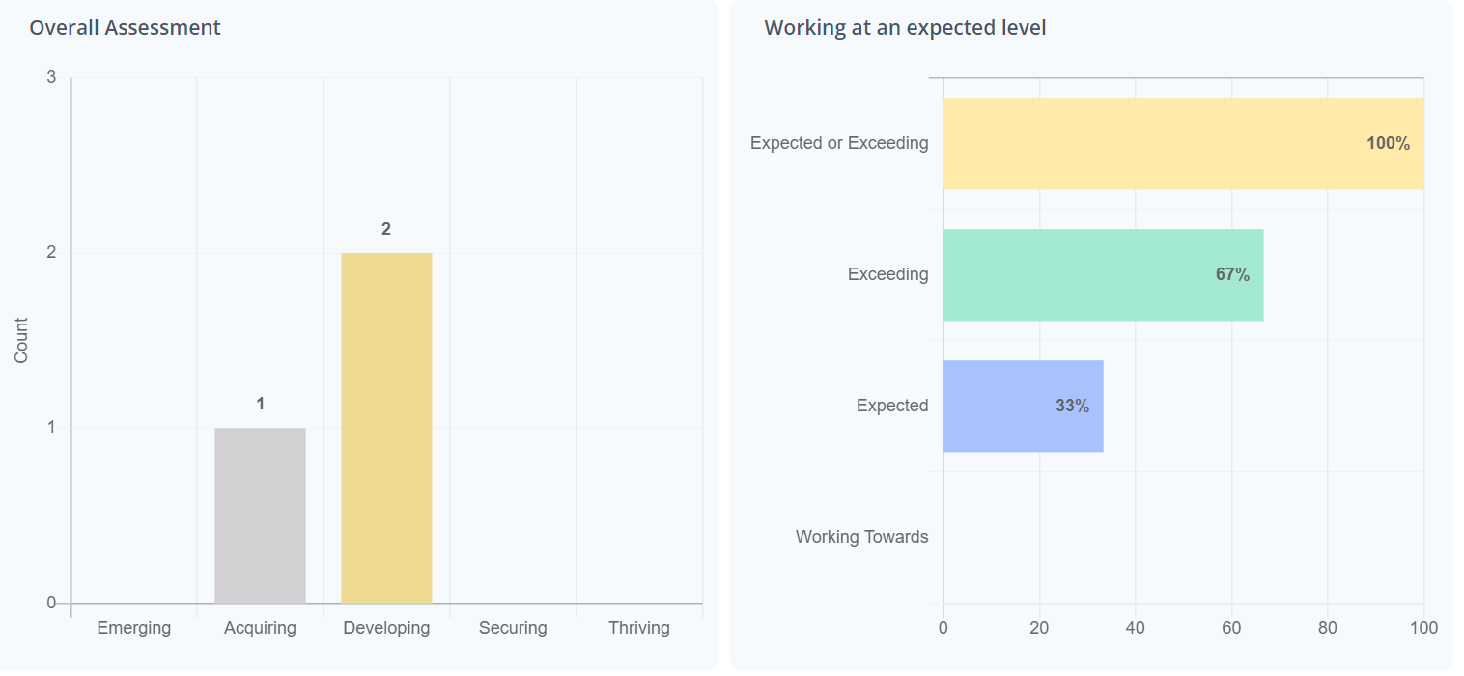

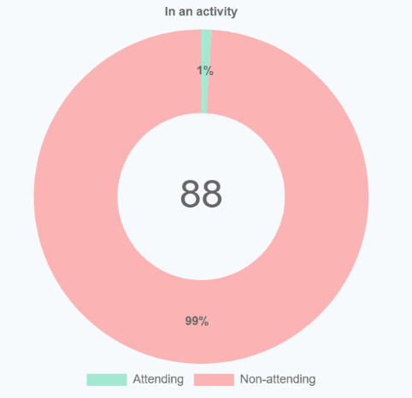
Whole-school extra-curricular club attendance:

Whole-School events data:
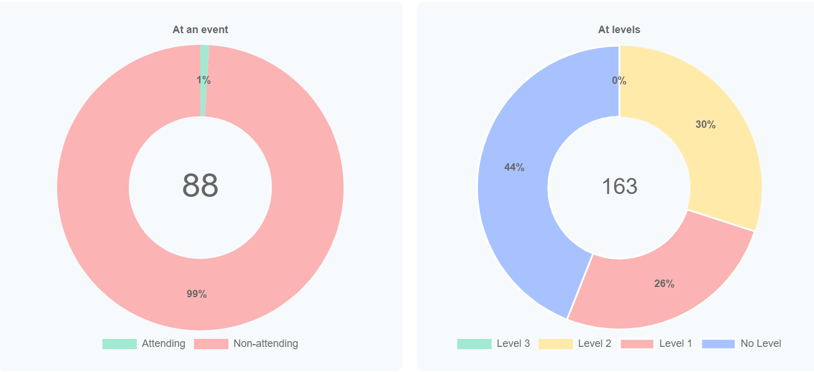

Y6 Swimming data:


