 |  |  | SOUTHERY ACADEMY LONG TERM PLAN
Subject |  |  | English (Writing) – Jane Considine
Leader |  |  | Jonathan Parrish
ACADEMIC YEAR |  |  | 2022-2023
Year  Group | Autumn 1 | Autumn 2 |  | Spring 1 | Spring 2 | Summer 1 | Summer 2
R | 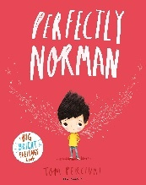  Perfectly Norman (Narrative) | We’re Going on a Bear Hunt  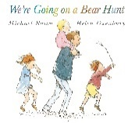  (Narrative) |  | 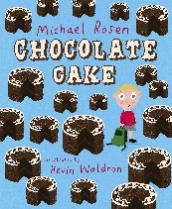  Chocolate Mug Cake (Instructions) | 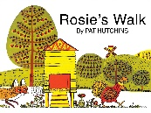  Rosie’s Walk (Narrative)  Handa’s Surprise  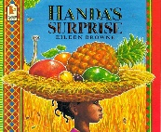  (Narrative) | Where the Wild Things Are  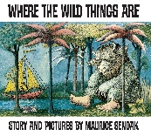  (Narrative)  I Wanna Iguana  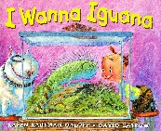  (Persuasive Letter) | 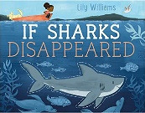  If Sharks Disappeared (Report)  The Snail and the Whale  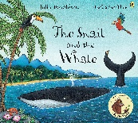  (Postcard)
1 | Wombat goes Walkabout  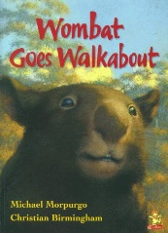  (Narrative)  Ice Planet Adventure Park  (Persuasive leaflet) | Our Trip to the Woods (Recount)  Firework Night (Poetry) |  | Pinocchio  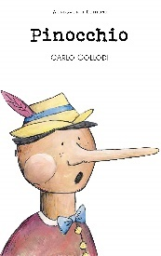  (Narrative) | Little Red Riding Hood (Narrative)  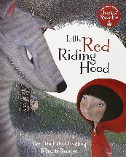  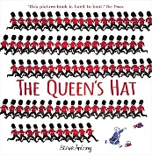  The Queen’s Hat (Narrative) | Bold Women in Black History  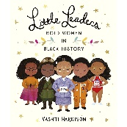  (Biography)  When I am by Myself (Poetry) | 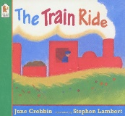  The Train Ride (Narrative)
2 | 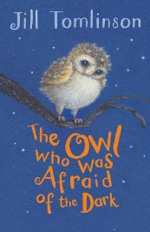  The Owl who was Afraid of the Dark (Narrative) | The Day the Crayons Quit  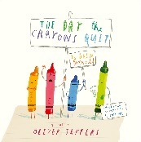  (Persuasive letter) |  | Desk Diddler  (Poetry)  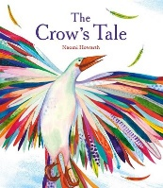  The Crows Tale (Narrative) | Hibernation  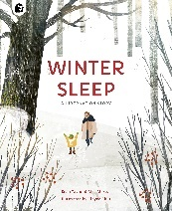  (Non-chronological Report) | George and the Dragon  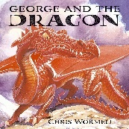  (Narrative) | Grace Darling (Biography)  If I were in charge of the World  (Poetry)
3 | The Incredible Book Eating Boy  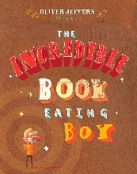  (Narrative)  Autumn is here (Poetry) | 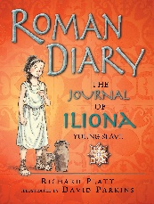  The Journal of Iliona (Diary) |  | 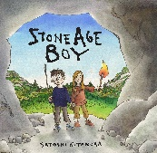  Stone Age Boy (Narrative)  Earthquakes  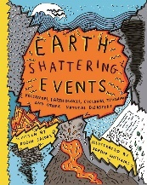  (Non-chronological Report) | 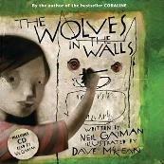  Wolves in the Walls (Narrative) | I asked the little boy who couldn’t see (Poetry)  Street Beneath my Feet  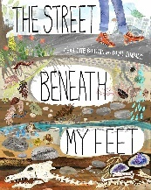  (Explanation) | Theseus and the Minotaur  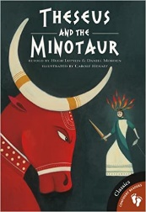  (Narrative)
4 | 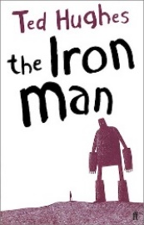  The Iron Man (Narrative)  Still I Rise  (Poetry) | The Creature (Journalistic) |  | 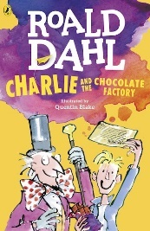  Charlie and the Chocolate Factory (Narrative) | Should we feed animals at National Parks?  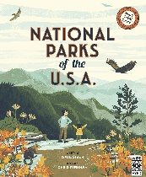  (Balanced Argument) | 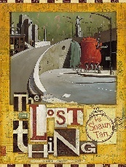  The Lost Thing (Narrative)  Once upon a raindrop  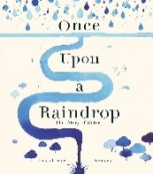  (Script for factual tour) | The Plague (Playscript)  Sicily Holiday Brochure  (Persuasive)
5 | 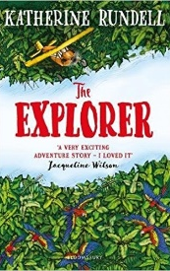  The Explorer (Narrative)  The Malfeasance (Poetry) | The Snowman (Narrative)  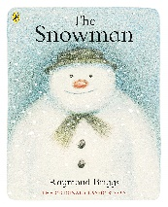 |  | 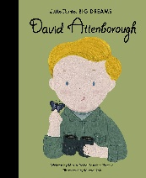  David Attenborough (Biography) | Gorilla  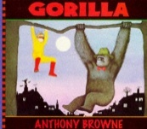  (Narrative) | The Highwayman (Poetry)  Mars Transmission (Journal) | 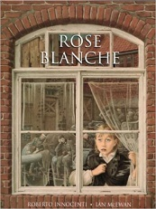  Rose Blanche (Narrative)  Refugees  (Speech)
6 | Kensuke’s Kingdom (Narrative)  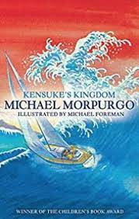 | 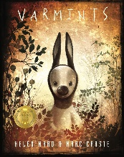  Varmints  (Narrative)  Scrooge  (Formal Persuasive Letter) |  | Everest  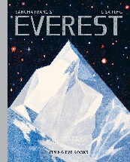  (Non-chronological report)  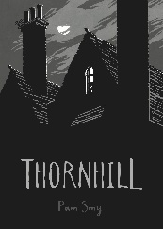  Thornhill (Narrative) | Thinkers Rap  (Poetry) | A Monster Calls (Narrative)  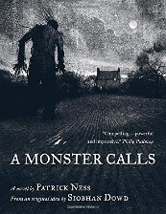 | Charles Darwin Origin of Species  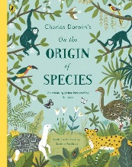  (Non-chronological Report)

