Cross Country and Health Related Fitness Knowledge Organiser
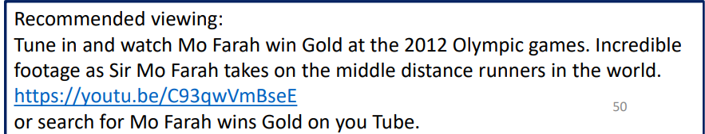
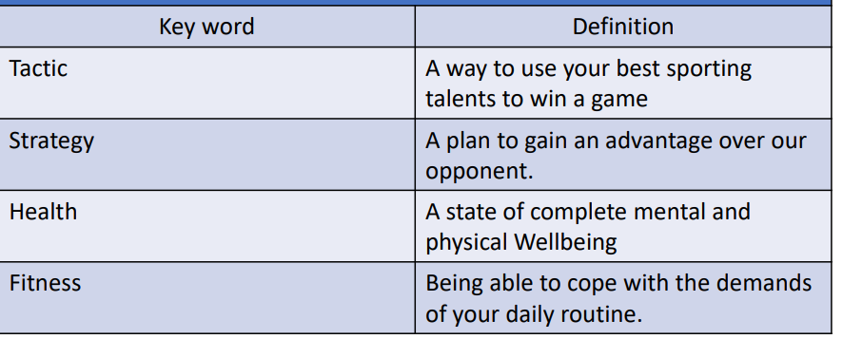
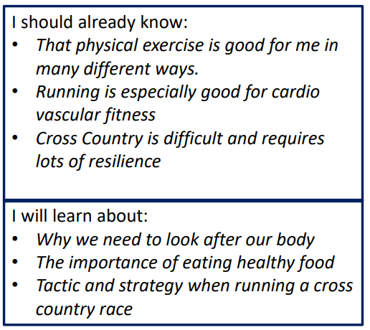

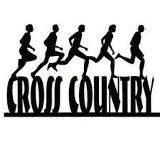
Would you like to take part in a cluster cross country event?

