A neighbourhood or area.
Something or someone very important.
A large area of land which has a noticeable characteristic.
An area of a country which usually includes several towns and countryside.
A small place with its own church.
A group of people who live in the same area or who have something in common.
Southery in the Present Day
Southery in the Past
locality
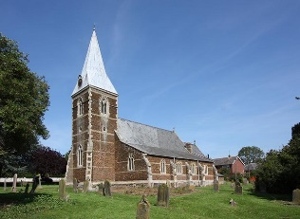
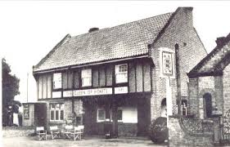
significant
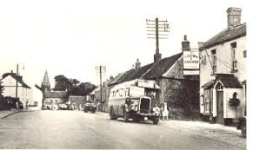
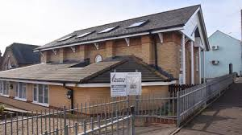
(The name Southery derives from the Old English phrase meaning 'Southern Island'. The parish has a long history and was certainly well established by the time of the Norman Conquest with its population, land ownership and productive resources detailed in the Domesday Book of 1086.
An area of country, city or town.
Early History of Southery
region
community
district
parish
county
Events that happened a long time ago and cannot be remembered by people who are alive today.
The history and traditions of a particular area
or culture that are significant today.
A walking trail, often in a public place, that highlights important cultural objects, such as buildings, from the past.
(Insert current map of local area.)
(Insert map of local area from the past.)
Current Map of (local area)
Map of (local area) from (date)
(Insert image and name of important person from the local area.)
(Explain what they are famous for.)
What They Are Known For
Significant Individuals from the Local Community
(Insert key buildings or sites in the local area that have historical importance.)
Examples of Heritage in the Locality
A time that can be remembered by people who are still alive.
beyond living memory
heritage trail
living memory
heritage
There are four seasons each year, autumn, winter, spring and summer.
autumn

seasons

