A Message from the Principal:
Dear Parents and Carers,
Welcome back to school and to our Autumn Term. Last week was absolutely fantastic – the start that each class has made, is just amazing! Our assembly on Friday was a great testament to the hard work we all put in each day, including you, our parents, into helping our children to be ready, use their good manners and always try their best. We have made some amendments as is always expected, for some of our children, particularly those new to us, so that everyone can come into school each day feeling safe and happy. Please do keep in touch with us, if there is anything else you feel might help. We ask that the class teachers are your first point of contact, but you can always email me if you feel you need to. Your new Dojo class pages should now all be up and running too – the best way to stay in touch.
This year we will continue to have a big push for all children to develop a love for reading and those very important skills, needed to be successful. Please use Fonetti at home, and contact us if you need another log-in. This online reading resource is designed to help busy families ensure all children can read as often as they want.
In addition we will be helping all our lovely children to believe in themselves, to give them confidence to know they can achieve anything they set out to and give them all hope in all they do. Another area for further development is in Oracy – we will be helping our children with their ability to put thoughts into words, confidently and fluently, and to help them with listening and responding skills. These skills follow our governments ambitions through the revised curriculum guidance.
There will be more on our plans for this year very soon, including the official opening of our new ‘garden’ area and our 150 year celebrations in October.
We will also be building our parent volunteers too, so let us know if you think you can help in any way. Thank you for your continued support. Kind regards, Mrs Huntington
STAFFING UPDATE:

A big thank you to for the many end of term gifts and kind words. I know the staff were very grateful.
After a period of absence, Mrs Short will not be returning to Southery Academy. We thank Mrs Short for her time at Southery and wish her well in her future. Naturally, we will be recruiting soon, and will keep you all informed of any further changes. We do not expect a new Ops Manager to be in post until half term. In the meantime, our existing staff are doing some additional hours to cover this post. Mrs Smith will be in the office first thing, and from 11.45 until 4 each day, plus all day on Tuesday. Mrs Marsh is also going to be doing some hours in the office so you will see familiar faces!

Southery Academy is 150, in October 2026! Look out for our celebration activities and ways you can be part of our history!
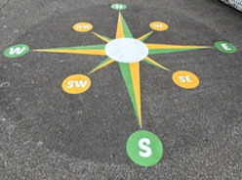

Buildings and renovations
During the summer holidays we have had some extensive roof repairs, changes to our drains and associated internal renovations. This has included a completely refurbished staff room which was very long over due! Swans have also got a new kitchen area with a new floor and our water damaged ceiling tiles are now replaced. In the hall we also now have a dedicated breakfast storage and serving area.
Outside you will see we have had a lot of new playground markings which will help with playtimes and lunchtimes, plus the very end part of our field has been completely re-turfed. This has given us an area we are developing as a sensory garden, more space for our forest school, an area to compost and access more easily, and a squarer, larger area for sports.
We would like to thank Smiths Builders and Steven Flemming for the work they have done. We hope you will agree, these developments are such a positive changes to our school environment.



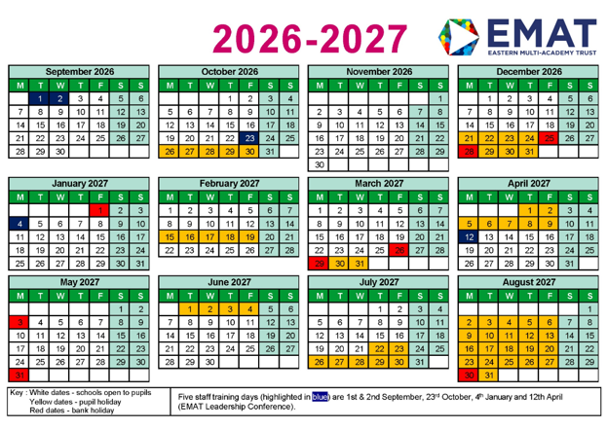
TERM DATES
Dates for events and school activities will follow very soon. We are finalizing many of these at our staff meeting on Monday.
BLUE – INSET days/closed to children
RED – Bank holidays
YELLOW – school holidays

Parent volunteers
We would like to expand our super band of parent volunteers this year. We would love to see more of you getting involved in supporting reading in class, helping in various other ways in school or helping us our fundraising and social events. It is hard to do these with a small staff and your input is very much appreciated.
Please keep an eye on the Dojo Calendar for up coming events.
We will also be re-launching our fundraising committee and organization and would love to get you all involved. Please look out for our new campaign details soon, and think about what you would like to see at our school to raise funds, create community activities and give further enrichment for our children.

