Southery Academy PE Report 2023-2024
Throughout the 2023 and 2024 academic year, the provision of PE and Sport at Southery Academy has continued to develop and progress. Below, there are some notable developments and achievements that have occurred throughout this academic year:
- Southery Academy have been awarded a GOLD award for Norfolk School Games
- Southery Academy have been awarded a SILVER award for both KS1 and KS2 Norfolk PE Sporting Stars
- We have continued to implement and adapt the PE curriculum alongside the PE Passport and events (our working wall use in PE has developed further and runs in the same way as other curriculum areas by using the subject map showing composites and components linked to events, seasons and other class composites, as well as key vocabulary and Knowledge Organisers)
- Sports events wall is regularly updated with certificates, photos and information relating to our sporting achievements as and when they happen throughout the year (this is to be developed into a timeline in 24-25)
- PE Store and PE shed are organised with up-to-date equipment ready to be used (PE office area to come with a designated space for PE staff to work on planning, assessment and reviewing of the subject)
- Completed the annual PE equipment audit leading to ordering new/replacement equipment
- Extended the offer of after-school activities including new clubs (multi-sports, football, competition preparation clubs, dance, darts and more)
- Relaunched lunchtime sports activities led by staff and playleaders
- Y5 children have completed the Young Leader’s Course, qualifying as playleaders leading to a new playleader rota and child-led activities being implemented in September
- PE subject leader folder is now online and accessible to staff across the school to improve PE staff workload and wellbeing as well as to make the subject more accessible and transparent
- A monitoring schedule is in place to manage the provision of PE teaching ready for September
- Order of new playtime and lunchtime play equipment to support playleaders and our PE instructor
- Playtime and lunchtime equipment class boxes have been organised and led by playleaders and PE staff
- Success in a competition to win a new Nike sports kit
- Every child in the school has been given the opportunity to participate in at least one club, event or competition
- Competed in competitions with more children being able to reach next level events
- Competed in interclass competitions
- Started to develop staff progression through the use of CPD/shadowing/networking
- Amended our swimming timetable to improve quality of provision and to increase the number of children attending each week, and to reflect data accurately as well as give the Year 5s a chance to develop before they reach Year 6 stage
- Continued the tracking and assessment of PE progress, identifying gaps and key information (scheduled half-termly meetings in place from September)
- Implemented the same ‘Good to be Green’ behaviour system used in all lessons that mirror class systems
- Held a whole-school PE assembly to re-establish expectations and promote key values/opportunities
- Updated and improved PE risk assessments to reflect current situations
- Our annual Sports Week was a huge success with children enjoying their time competing and participating in new sports, competing against each other learning about new sports (events every day, new opportunities, visitors)
- Our annual Sports Day was a huge success, receiving fantastic feedback from children, parents and staff
- Sporting visitors have been a highlight and children have enjoyed being able to meet ‘real-life superheroes’ (Kieran Lambourne – England & Chelsea Amputee Goalkeeper, Sean Rose Team GB Paralympic Adventurer)
See below data for the whole school’s PE attainment, as well as data from extra-curricular clubs and events/competitions.
Whole-School PE attainment:
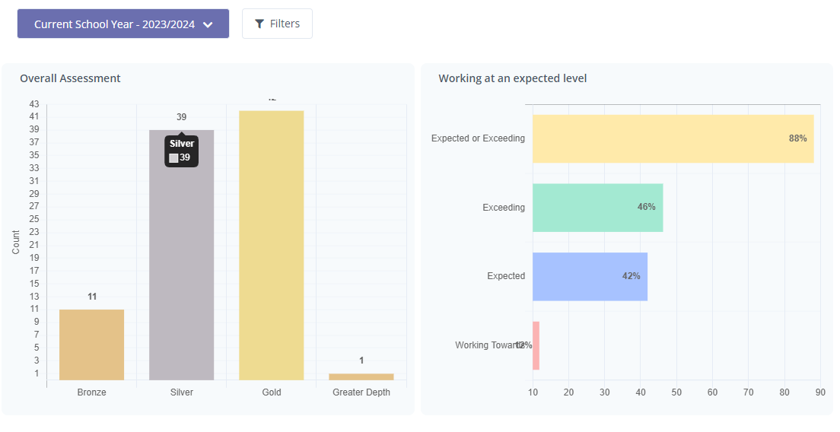
Reception:

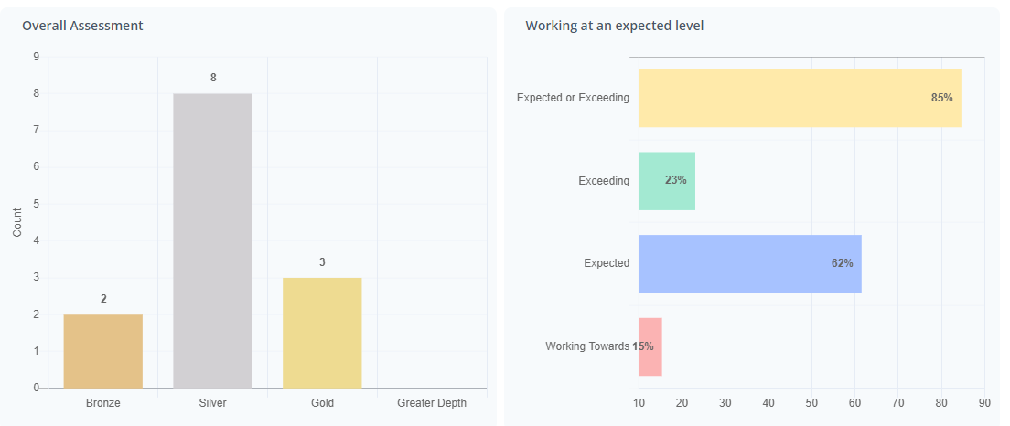

Year 1:

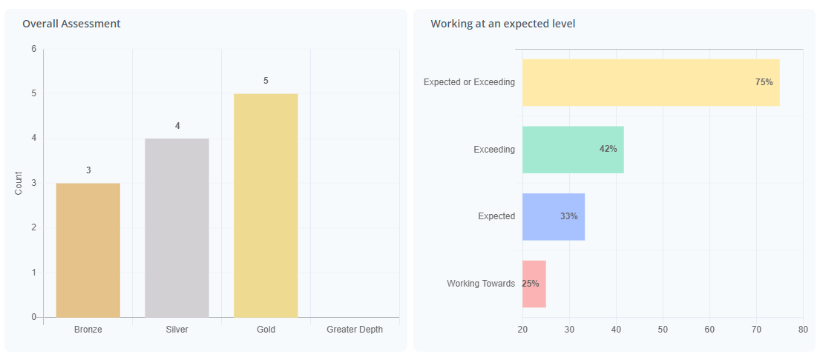
Year 2:
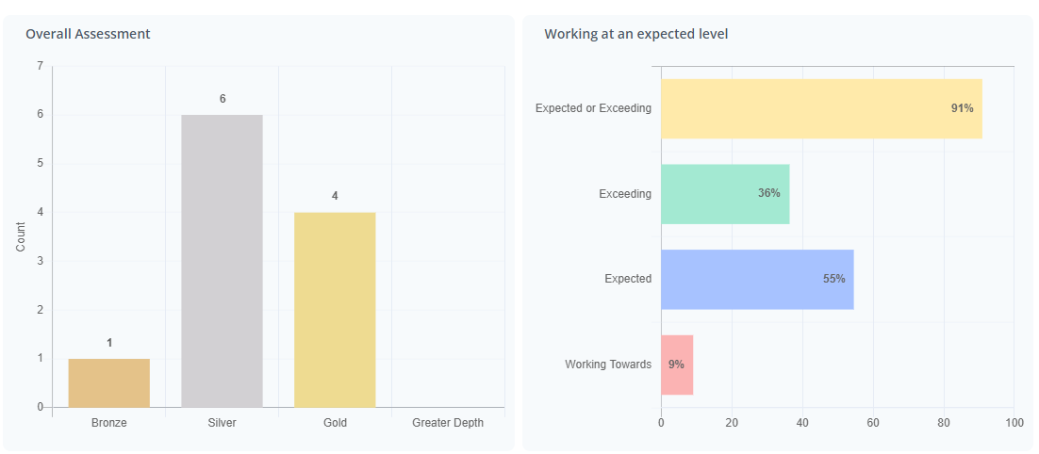
Year 3:
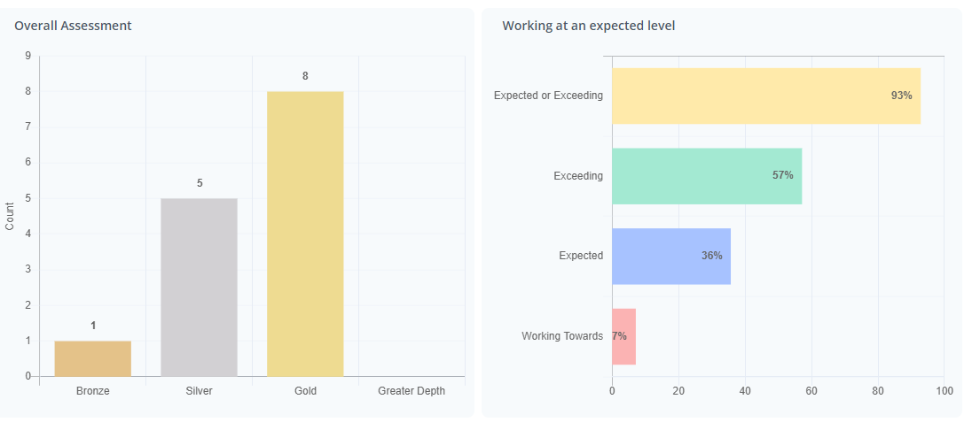
Year 4:
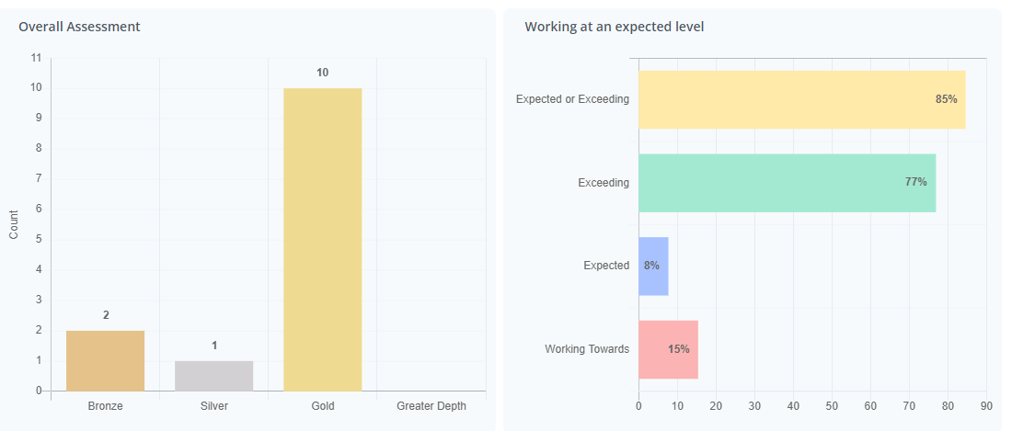
Year 5:
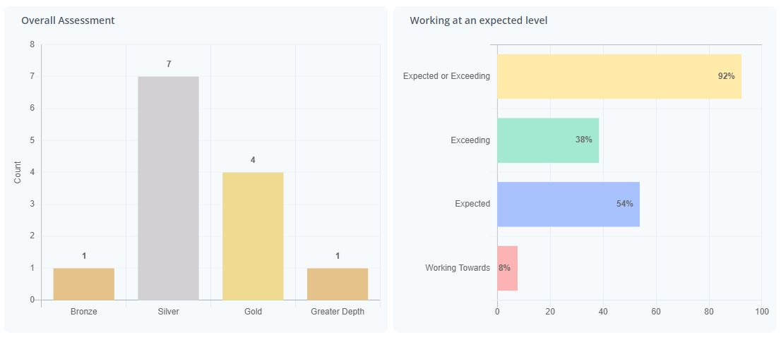
Year 6:
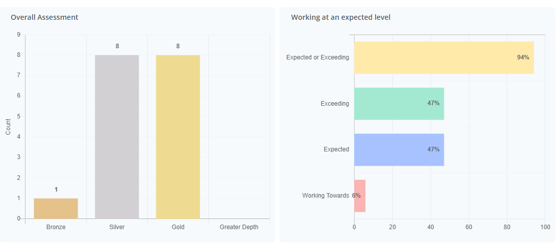
Male:
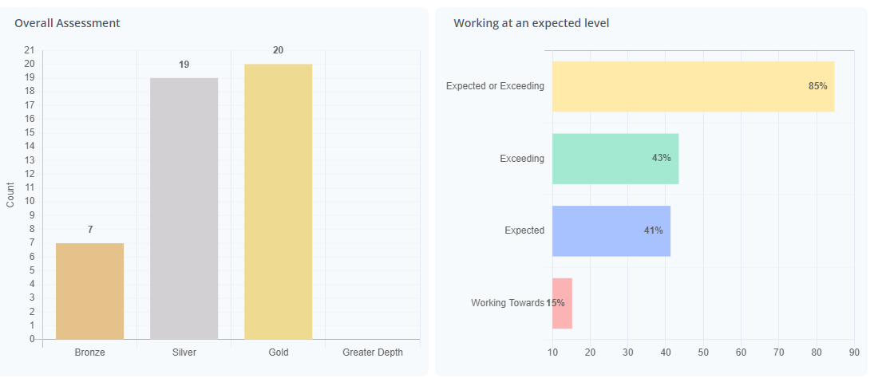
Female:
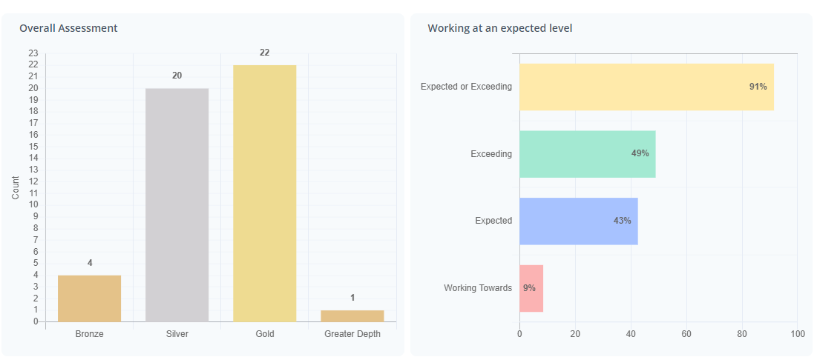
Pupil Premium:
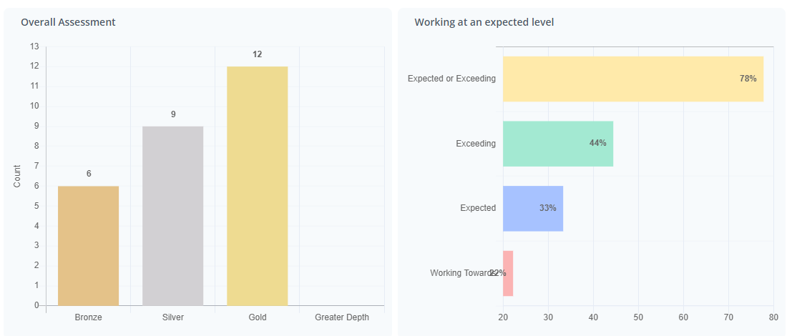

SEND:
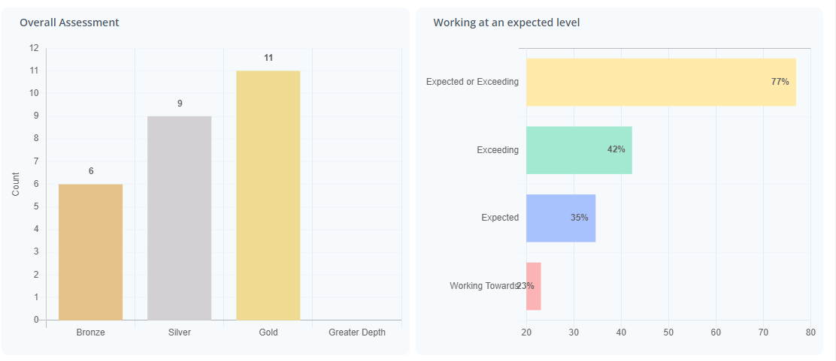
EAL:
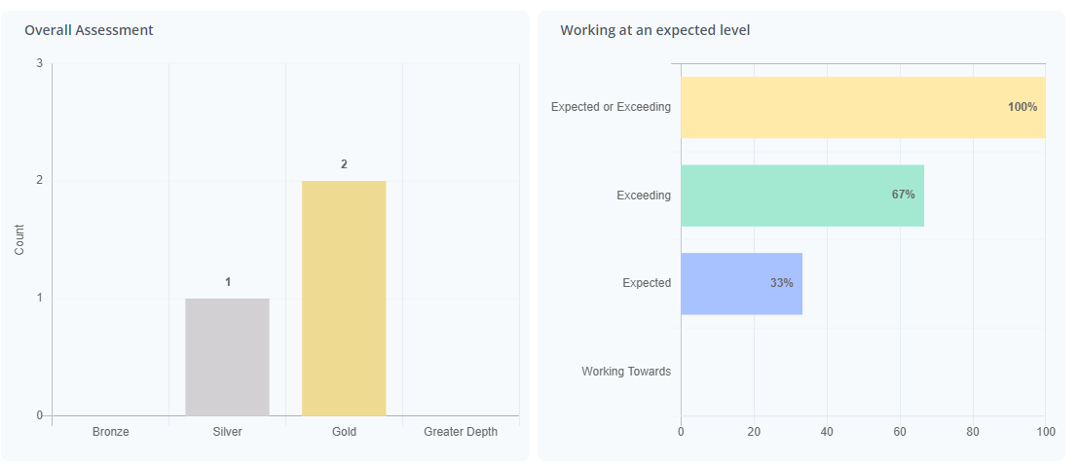
Whole-school extra-curricular club attendance:

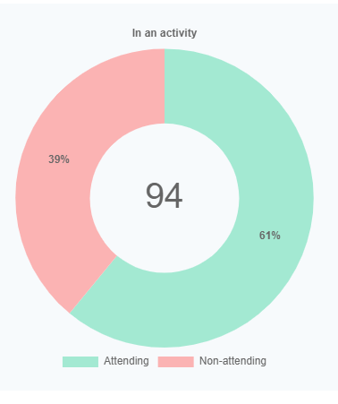
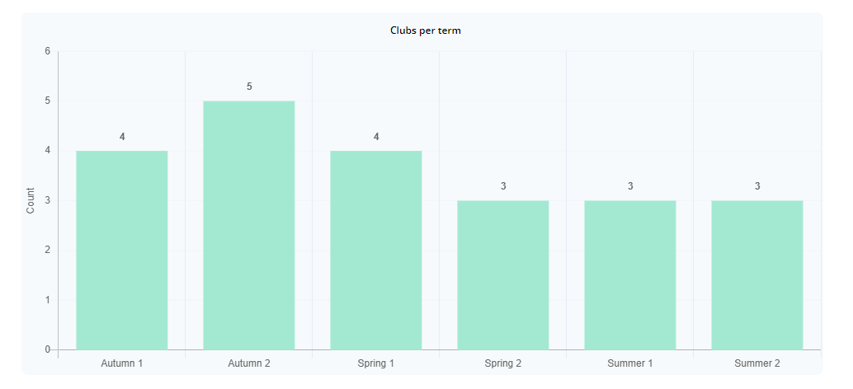
Whole-School events data:
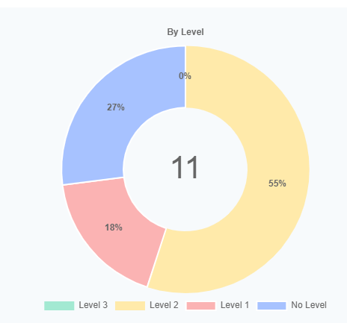
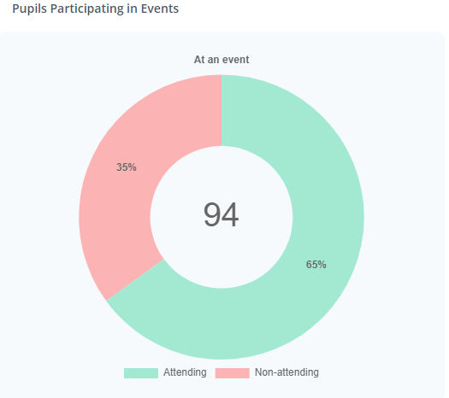

Y6 Swimming data:
What percentage of your current Year 6 cohort can swim competently, confidently and proficiently over a distance of at least 25 metres? 72%

What percentage of your current Year 6 cohort can use a range of strokes effectively [for example, front crawl, backstroke, and breaststroke]? 90%

What percentage of your current Year 6 cohort are able to perform safe self-rescue in different water-based situations? 93%

