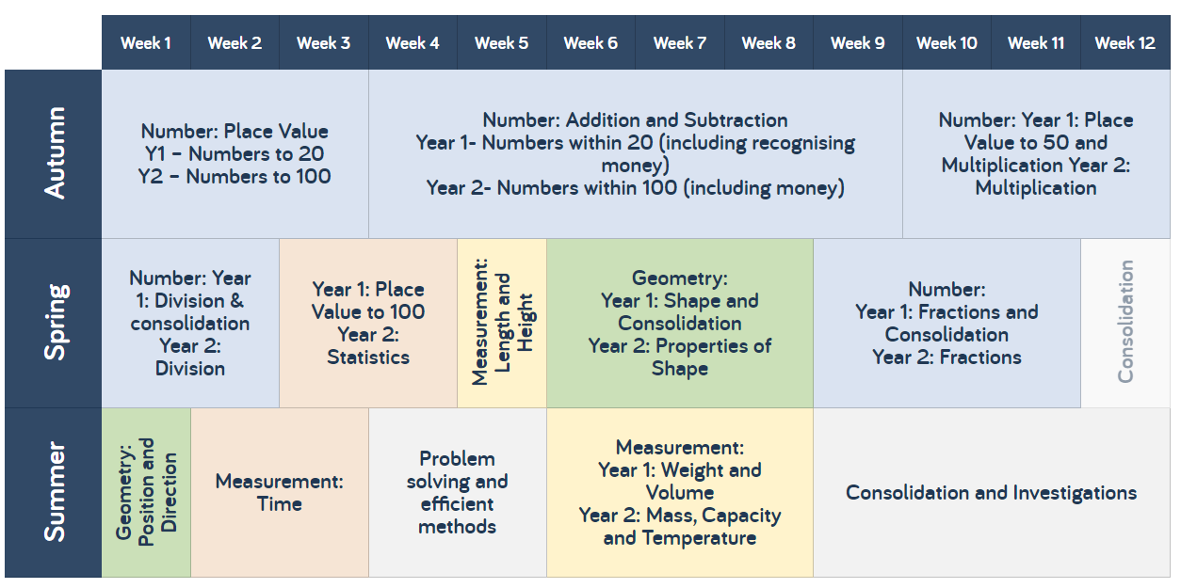
Use this long-term plan to navigate to each area’s SOL document. This shows common themes and year group specific themes with reference to the area to find the lesson content. Use this to make each unit plan.

